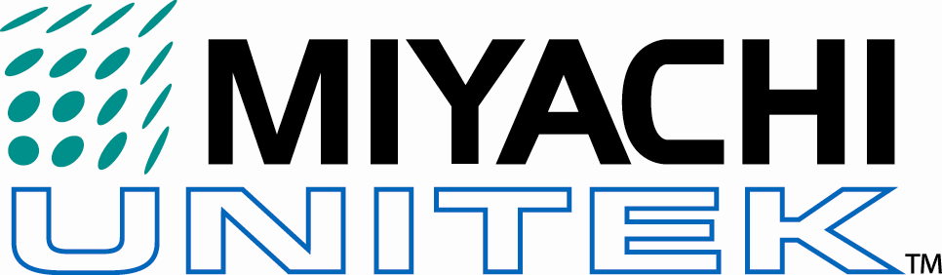
Welding Evaluation Request Form

Date: _____________
Salesforce
Contact Name |  |  | Dist./Rep Co.
Title |  |  | Sales Engineer  Phone #:
Company |  |  | Regional Manager  Phone #:
Address |  |  | Return samples to: | Rep: |  | Cust: |  | RM:
City, State, Zip |  |  | Confidentiality Agreement Required? |  | Yes: |  | No:
 |  |  |  |  | On Rec: |  | N/A:
Country | Samples will be assessed and completed based on the quality and detail of information supplied. Please attach all relevant information and drawings. Enclose at least 25 sample parts, or as many as needed, for a successful evaluation.
Phone
Fax
Email
CUSTOMER INFORMATION Opportunity Name: ___________ ______

PROJECT INFORMATION
New application? Yes No |  | Is the project budgeted? Yes No
Existing equipment (describe): |  | Budget per system: $
Existing equipment (describe): |  | How soon is the equipment required?
Existing equipment (describe): |  | Low- 3 or more months, sample turnaround 15 days
New equipment required? Yes No |  | Medium- 1-3 months, sample turnaround 10 days
Proposed new equipment: |  | Urgent- 1 month or less, sample turnaround 5 days
Production rate: parts/hr |  | Available Facility Power:  Voltage: Phases: 1 3
No. of units required? |  | Industry:
Automation Bench
Weld head actuation: Electromagnetic Air Foot

APPLICATION INFORMATION
Weldments: | Part 1: | Part 2: | Part 3:
Material:
Size:
Shape:
Plating:
Insulation:
Customer End Product:

SOLUTION CRITERIA
Assembly sketch/ notes (Attach further details.)

Mechanical Strength, Visual Appearance, Etc.

Applications Lab: 1820 S. Myrtle Ave. • Monrovia, CA 91016 • Tel: (626) 303-5676 • Fax: (626) 358-8048 www.miyachiunitek.com

